Supply Chain Management (SCM) — NPTEL
Week 9 · Session 4: Intelligent Decision Tools — Efficiency Measurement & Data Envelopment Analysis (DEA)
1. Context — New Case Study
- Previous 3 sessions: K-means clustering for DC location (pharma case)
- This session: new intelligent decision tool — Data Envelopment Analysis (DEA) for facility efficiency measurement
- Next session: solve the DEA model and interpret outputs

2. Case Study — Automotive Company: 9 Manufacturing Facilities
Problem Statement
- Senior management wants to measure efficiency of 9 manufacturing facilities
- Goal: identify which facilities are efficient, which are not, and where to improve
- Improvement options: increase outputs OR reduce inputs
 | Output 1 | Output 2 | Input 1 | Input 2
Facility | Production Yield (%) | OEE (%) | Cycle Time (minutes) | Resource Utilization (%)
1 | 92 | 80 | 32 | 88
2 | 88 | 78 | 35 | 94
3 | 92 | 81 | 31 | 95
4 | 90 | 78 | 30 | 82
5 | 90 | 82 | 34 | 90
6 | 82 | 76 | 36 | 89
7 | 96 | 85 | 31 | 91
8 | 74 | 68 | 35 | 94
9 | 78 | 76 | 30 | 89

Parameters Collected
- Output 1 — Production Yield: % of defect-free products
- Output 2 — OEE (Overall Equipment Effectiveness): % — measures availability, performance, quality combined
- Input 1 — Cycle Time: minutes to complete one production cycle
- Input 2 — Resource Utilization: % use of machinery, equipment, labour

★ Higher outputs = better. Lower inputs = better. Efficiency = getting more output per unit of input.

Data — All 9 Facilities
Facility | Output 1 Prod Yield (%) | Output 2 OEE (%) | Input 1 Cycle Time (min) | Input 2 Resource Util (%) | Note
F1 | 92 | 80 | 32 | 88
F2 | 88 | 78 | 35 | 94
F3 | 92 | 82 | 33 | 86
F4 | 85 | 75 | 30 | 92
F5 | 90 | 80 | 34 | 90
F6 | 88 | 79 | 38 | 89
F7 | 96 | 85 | 31 | 87 | ★ Best OEE & Yield
F8 | 74 | 68 | 35 | 94 | ✗ Worst OEE & Yield
F9 | 91 | 83 | 30 | 85

- Best facility: F7 — highest production yield (96%) and highest OEE (85%)
- Worst facility: F8 — lowest production yield (74%) and lowest OEE (68%)
- F4 & F9: best cycle time (30 min). F6: worst cycle time (38 min)

3. What is Efficiency? — 1 Input, 1 Output Example
- Before tackling 2 inputs / 2 outputs, understand efficiency with a simpler 5-facility example

Basic Efficiency Formula

Efficiency = Output / Input
subject to: Efficiency ≤ 1

- Raw Output / Input may exceed 1 (e.g., if output > input)
- Normalize: divide all ratios by the maximum ratio across all facilities
- This ensures maximum efficiency = 1.0 and all others ≤ 1
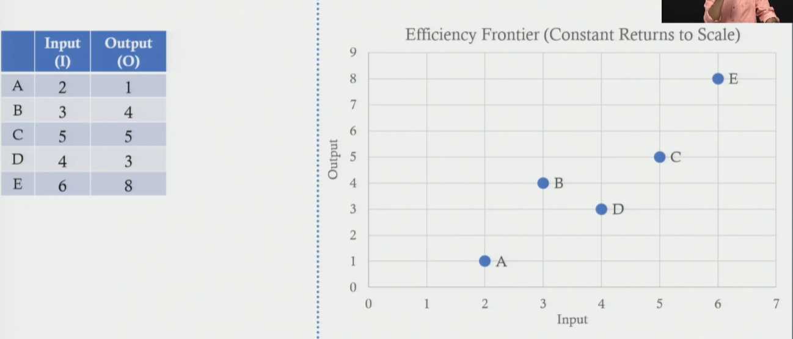
5-Facility Example Calculation
Facility | Input | Output | Output / Input | ÷ Max (1.33) | Efficiency | Status
A | 2 | 1 | 0.50 | 0.375 | 37.5% | Not efficient
B | 3 | 4 | 1.33 | 1.000 | 100% | Efficient ★
C | 5 | 5 | 1.00 | 0.750 | 75% | Not efficient
D | 4 | 3 | 0.75 | 0.563 | 56.3% | Not efficient
E | 6 | 8 | 1.33 | 1.000 | 100% | Efficient ★

- Max raw ratio = 1.33 (B and E tie). Divide all ratios by 1.33 to get efficiency scores
- B and E are efficient (score = 1.0) → they lie on the efficient frontier
- A (37.5%), C (75%), D (56.3%) are inefficient → lie below the frontier

4. Efficient Frontier
- A line / curve connecting all facilities with efficiency = 1.0
- Efficient facilities already lie ON the frontier — no improvement needed
- Inefficient facilities lie BELOW the frontier — have room to improve
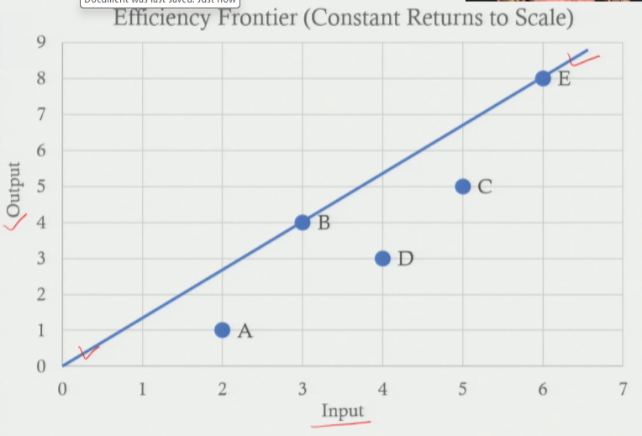
How to Make an Inefficient Facility Efficient
- Two strategies — choose based on resources available:
- Option 1 — Increase output: with the same input, produce more → move UP to the frontier
- Option 2 — Reduce input: produce the same output with less input → move LEFT to the frontier

★ DEA tells you BOTH how far from the frontier a facility is AND by how much it needs to improve inputs/outputs to become efficient.

5. Efficiency with Multiple Inputs & Outputs
- Case study has: 2 outputs (Production Yield, OEE) + 2 inputs (Cycle Time, Resource Util)
- Simple O/I ratio no longer works — need weighted formula

Efficiency = Weighted Sum of Outputs ÷ Weighted Sum of Inputs
= (V1·Y1 + V2·Y2) ÷ (U1·X1 + U2·X2) ≤ 1

- V1, V2 = weights assigned to Output 1 and Output 2
- U1, U2 = weights assigned to Input 1 and Input 2
- These weights are decision variables — Solver finds the optimal values

Decision Variables — DEA Model
Variable | Meaning | Type
V1 | Weight of Output 1 (Production Yield) | Output weight
V2 | Weight of Output 2 (OEE) | Output weight
U1 | Weight of Input 1 (Cycle Time) | Input weight
U2 | Weight of Input 2 (Resource Utilization) | Input weight

6. DEA Model Formulation
- Data Envelopment Analysis (DEA) — optimization model to find efficiency scores for each facility
- Run the model 9 times — once per facility. Only the objective function changes
- Constraints remain the same for all 9 runs

Component | Expression (for Facility k) | Explanation
Objective (changes per facility) | Maximize:  (Yk1·V1 + Yk2·V2) ÷ (Xk1·U1 + Xk2·U2) | Maximize weighted output ÷ weighted input for the target facility k. Solve once per facility.
Constraint (same for all 9 runs) | For each facility i = 1 to 9:  (Yi1·V1 + Yi2·V2) ÷ (Xi1·U1 + Xi2·U2) ≤ 1 | Ensures NO facility is allowed efficiency > 1. Same 9 constraints for every run.
Decision Variables | V1, V2 (output weights)  U1, U2 (input weights) | 4 unknowns — Solver finds optimal values that maximize target facility's efficiency.
Non- negativity | V1, V2, U1, U2 ≥ 0 | Weights cannot be negative.

Objective Functions — Examples
Target | Objective Function: Maximize... | Constraints
F1 | (92·V1 + 80·V2) ÷ (32·U1 + 88·U2) | Same 9 constraints
F5 | (90·V1 + 80·V2) ÷ (34·U1 + 90·U2) | Same 9 constraints
F8 | (74·V1 + 68·V2) ÷ (35·U1 + 94·U2) | Same 9 constraints
F2–F9 | Similar pattern — substitute that facility's data values | Same 9 constraints

- For each facility run: Solver finds V1, V2, U1, U2 that maximize that facility's efficiency without letting any other facility exceed 1
- Plug V1, V2, U1, U2 back into the formula → get efficiency score for target facility

★ DEA does NOT use the same weights for all facilities. Each facility gets the most FAVOURABLE weights to maximize its own efficiency score.

7. DEA Model — Quick Reference
- Technique: Data Envelopment Analysis (DEA) — optimization-based efficiency measurement
- No. of runs: 9 (one per facility) — only objective function changes each time
- Decision variables: V1, V2 (output weights), U1, U2 (input weights) — 4 unknowns
- Objective: Maximize weighted output ÷ weighted input for target facility
- Constraint: efficiency of ALL 9 facilities ≤ 1 (same 9 constraints every run)
- Output: efficiency score per facility + targets for improvement (next session)

Session Summary
- Problem: measure efficiency of 9 automotive manufacturing facilities (2 inputs, 2 outputs)
- Efficiency: Output / Input, normalized so max = 1. Facilities with score = 1 are on the efficient frontier
- Efficient frontier: locus of best-performing facilities. Inefficient ones improve by ↑ output OR ↓ input
- Multiple I/O: use weighted sums — Efficiency = (V1·Y1+V2·Y2) ÷ (U1·X1+U2·X2) ≤ 1
- DEA model: LP solved 9 times — objective changes per facility, constraints are same
- Next session: solve the DEA model, get efficiency scores, interpret improvement targets

★ Exam Tip: DEA is solved separately for EACH facility (9 runs here). Objective function changes each time. Constraints (efficiency ≤ 1 for all facilities) stay the same.
★ Exam Tip: Efficiency ≤ 1 always — normalize by dividing by the highest raw O/I ratio. Facilities at exactly 1 are efficient; all others are not.
★ Exam Tip: Efficient frontier = line connecting all facilities with efficiency = 1. To reach it: EITHER increase output (same input) OR decrease input (same output).
★ Exam Tip: DEA weights (V1, V2, U1, U2) are the decision variables — not pre-set. Solver finds the MOST FAVOURABLE weights for each facility to maximize its score.

